**A MINI PROJECT REPORT ON**

### “Brain Tumor Detection”

SUBMITTED TOWARDS THE

PARTIAL FULFILLMENT OF THE REQUIREMENTS OF

**BACHELOR OF ENGINEERING (TE AI & DS)**

|  |  |
| --- | --- |
| Mr. Atharva R. Kalbhor | Roll No: TE18 |
| Ms. Sakshi M. Karekar | Roll No: TE20 |
| Ms. Nidhi C. Deshmukh | Roll No: TE24 |

**BY**

**Under The Guidance of**

Mr. Nisar Shaikh



“Excellence in the field of AI & DS”

# Department of Artificial Intelligence & Data Science

“Techno-Social Excellence”

# Marathwada Mitra Mandal's Institute of Technology

Lohgaon, Pune- 411 047

A. Y (2023-24)



“Techno-Social Excellence”

Marathwada Mitra Mandal’s

Institute of Technology

(MMIT) Lohgaon, Pune- 411 047

“Excellence in the field of AI & DS”

# Department of Artificial Intelligence & Data Science

### CERTIFICATE

This is to certify that the Report Entitled

“Brain Tumor Detection”

|  |  |
| --- | --- |
| Mr. Atharva R. Kalbhor | Roll No: TE18 |
| Ms. Sakshi M. Karekar | Roll No: TE20 |
| Ms. Nidhi C. Deshmukh | Roll No: TE24 |

Submitted by,

|  |  |
| --- | --- |
|  |  |
|  |  |

|  |  |
| --- | --- |
| Mr. Nisar Shaikh | Mr. Ashish K. Bhise |
| Internal Guide | H.O.D |
| Dept. of AI & DS | Dept. of AI & DS |

is a bonafide work carried out by students under the supervision of Mr. Nisar Shaikh and it is submitted towards the partial fulfillment of the requirement of Bachelor of Engineering (TE AI & DS) Environmental Studies.

### Abstract

This paper delves into the potential advancements that computer science and artificial intelligence (AI) offer in the realm of brain tumor detection and comprehension. Through an exploration of various brain imaging modalities, including MRI and CT scans, we investigate how AI can be harnessed to interpret this intricate data. Our analysis encompasses an examination of the merits and limitations of numerous computational methods, notably deep learning techniques. Furthermore, we explore the synergistic effects of integrating different AI approaches and leveraging extensive datasets of brain imagery for training purposes. Central to our inquiry is the proposition that AI holds the promise of accelerating and enhancing the accuracy of brain tumor identification, thus paving the way for more effective patient treatments. Additionally, we address crucial considerations surrounding privacy and ethics within this evolving landscape.

# INDEX

|  |  |  |
| --- | --- | --- |
| S. No | TOPIC NAME | PAGE NO |
| 1 | INTRODUCTION | 1 |
| 2 | OBJECTIVES OF SYSTEM | 2 |
| 3 | MOTIVATION | 3 |
| 4 | PROBLEM STATEMENT | 4 |
| 5 | PROPOSED SYSTEM | 5 |
| 6 | SYSTEM REQUIREMENT | 7 |
| 7 | IMPLEMENTATION | 8 |
| 8 | SNAPSHOTS | 9 |
| 9 | RESULTS | 10 |
| 10 | FUTURE SCOPE | 11 |
| 11 | CONCLUSION | 13 |
| 12 | REFERENCES | 14 |

**INTRODUCTION**

Brain tumour diagnosis is at a critical juncture in healthcare, requiring promptness and accuracy for successful treatments. Despite its basis, traditional diagnostic procedures frequently fail to achieve these requirements. Now let's talk about artificial intelligence (AI), where new developments in medical imaging technologies might change the way brain tumours are detected. In this study, we explore how machine learning, especially deep learning, might improve the efficiency and accuracy of diagnosis by travelling through the synergy between AI and several imaging modalities including MRI, CT, and PET scans. The social effects of incorporating AI into this field of healthcare in addition to its technological aspects. Our goal as we venture into these unexplored areas is to not only highlight the developments but also to highlight how AI has the revolutionary potential to revolutionise brain tumour diagnoses and improve patient care and healthcare outcomes.

In the field of medicine, brain tumour diagnosis is a difficult task that requires careful consideration of both the accuracy of the classification and the urgency of the detection. Even though they are fundamental, traditional diagnostic techniques frequently struggle with speed and accuracy issues. The intersection of artificial intelligence (AI) and medical imaging has become a ray of hope in recent years, bringing with it the possibility of a paradigm change in the field of brain tumour diagnosis. In order to better understand how AI technologies might revolutionise the effectiveness and efficiency of brain tumour diagnosis using a variety of imaging modalities, such as MRI, CT, and PET scans, this study will investigate this junction. Our goal is to offer a comprehensive knowledge of how machine learning algorithms, particularly deep learning, may improve diagnostic skills and open the door to individualised and focused treatment plans. We will accomplish this by thoroughly examining these algorithms. Beyond the technological aspects, we explore the ethical ones, thinking about patient privacy, openness, and the fair application of AI in healthcare. Our main objective is to highlight the revolutionary influence of AI on brain tumour diagnosis as well as the developments in this dynamic field, foreseeing a day when better patient outcomes and cost-effective healthcare would coexist.

**OBJECTIVES OF SYSTEM**

The primary objective of the Brain Tumor Detection project is to develop and implement sophisticated software solutions tailored to assist medical professionals in accurately identifying brain tumors and understanding their underlying causes. By leveraging advanced algorithms and cutting-edge technology, the software aims to enhance diagnostic accuracy and precision, thereby providing doctors with valuable tools to navigate the complexities of brain tumor diagnosis. Through the integration of various brain imaging modalities, such as MRI and CT scans, the software will empower clinicians to analyze and interpret data with greater efficiency and effectiveness.

One of the key goals of the project is to streamline the diagnostic process and minimize patient waiting times. By optimizing workflow efficiencies, the software aims to expedite the diagnostic journey, ensuring that patients receive timely evaluations and interventions. This emphasis on swift access to medical evaluations is crucial for improving patient outcomes, as early detection and intervention are often associated with better prognoses in brain tumor cases.

Furthermore, the project seeks to focus on early detection capabilities, enabling medical professionals to identify brain tumors at their earliest detectable stages. Early detection is paramount in the management of brain tumors, as it allows for prompt initiation of treatment and intervention strategies. By addressing brain tumor cases at their inception, the software aims to improve patient outcomes and quality of life.

In addition to facilitating accurate diagnosis and early detection, the project also aims to establish mechanisms for enabling timely consultations and collaborations among healthcare providers. By leveraging technology to facilitate seamless communication and decision-making processes, the software will empower healthcare teams to work collaboratively in managing complex brain tumor cases. This interdisciplinary approach to patient care ensures that individuals receive comprehensive and coordinated treatment plans tailored to their unique needs and circumstances. Ultimately, the Brain Tumor Detection project is driven by a commitment to leveraging technology to improve patient outcomes, enhance diagnostic capabilities, and advance the field of brain tumor diagnosis and management.

**MOTIVATION**

Detecting brain tumors early is crucial for successful treatment and patient outcomes. However, traditional diagnostic methods often rely on manual interpretation of complex imaging data, leading to delays and potential errors in diagnosis. By leveraging the power of artificial intelligence (AI) and advanced computer algorithms, this project aims to revolutionize brain tumor detection, providing healthcare professionals with efficient and accurate tools for early diagnosis.

* Improve brain tumor diagnosis: Develop software to aid doctors in accurately identifying and understanding brain tumors and their underlying causes.
* Time-saving solutions: Streamline the diagnostic process to save valuable time for both medical professionals and patients.
* Early detection: Provide tools that enable early detection of brain tumors, facilitating timely interventions and improving patient outcomes.
* Timely consultation: Ensure that patients receive prompt consultation and treatment, reducing delays in accessing healthcare services.
* Harness technology: Utilize artificial intelligence and machine learning algorithms to analyze complex medical imaging data with speed and accuracy.
* Transformative impact: Revolutionize the diagnostic and management approaches for brain tumors, leading to better patient care and improved survival rates.
* Advance medical research: Contribute to the advancement of neuro-oncology research by analyzing large datasets of brain imaging scans and clinical data.

**PROBLEM STATEMENT**

The manual interpretation of brain imaging data for tumor detection is time-consuming and error-prone. There is a need for an automated system using AI and ML techniques to enhance the efficiency and accuracy of brain tumor detection. This project aims to develop such a system to facilitate early diagnosis and improve patient outcomes.

**PROPOSED SYSTEM**

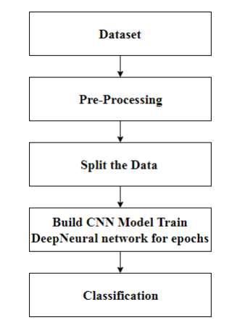

The proposed system has mainly five modules. Dataset, Pre-processing, Split the data, Build CNN model train Deep Neural network for epochs, and classification. In dataset we can take multiple MRI images and take one as input image. In pre-processing image to encoded the label and resize the image. In split the data we set the image as 80% Training Data and 20% Testing Data. Then build CNN model train deep neural network for epochs. Then classified the image as yes or no if tumor is positive then it returns yes and the tumor is negative then it returns no.

**HARDWARE REQUIREMENT**

* Processor: Intel Core i5
* RAM: 4GB
* OS: Windows / Mac
* GPU (Optional)
* Storage
* Internet Connectivity
* Integrated Development Environment (IDE)

**SOFTWARE REQUIREMENT**

**Python:** Python is the primary programming language for implementing the genetic algorithm. Ensure Python is installed on the development machine, preferably using a version management tool like Anaconda for library compatibility.

**NumPy and Matplotlib:** NumPy is a fundamental library for numerical operations in Python, and Matplotlib is essential for data visualization. These libraries will be beneficial for array manipulations and plotting results.

**Documentation Tools:** Use documentation tools like Sphinx or Jupyter Notebooks to create comprehensive project documentation, including code comments, explanations, and user guides.

**TensorFlow:** TensorFlow is a popular deep learning framework that provides tools for building and training neural networks, including convolutional neural networks (CNNs) for image classification tasks.

**Keras:** Keras is a high-level neural networks API that runs on top of TensorFlow. It simplifies the process of building and training deep learning models, making it ideal for rapid prototyping in medical image analysis projects.

**Scikit-learn:** Scikit-learn is a versatile machine learning library in Python that provides tools for data preprocessing, feature extraction, model evaluation, and more. It includes implementations of various classification algorithms like support vector machines (SVMs) and random forests.

**OpenCV:** OpenCV (Open Source Computer Vision Library) is a powerful library for computer vision tasks, including image processing and analysis. It offers functions for reading and manipulating medical image data, such as MRI scans.

**IMPLEMENTATION DETAIL**

**Convolutional Layer (Conv2D)**

A key component of our suggested neural network design for medical image processing is the Convolutional Layer, or Conv2D. The purpose of this layer is to extract complex characteristics and patterns from the input pictures, which are essential for tumour identification. Complexity is added to the model by the non-linear activation functions that are applied after convolution, which makes it easier to extract more abstract and significant representations from the input data.

**Max Pooling Layer (MaxPooling2D)**

Following the Conv2D layers, we incorporated MaxPooling2D to down-sample the spatial dimensions of the feature maps. Max pooling helps retain essential information while reducing the computational burden, thereby enhancing the model's efficiency. The pooling layer focuses on preserving the most salient features, ensuring that the subsequent layers process a concise and informative representation of the input, which is particularly crucial in medical imaging where key diagnostic features might be localized.

**Flatten Layer**

The multi-dimensional array is converted into a one-dimensional vector using the Flatten layer once pertinent features have been extracted using convolution and down sampling.. The neural network may combine the extracted characteristics into a format that is appropriate for thorough analysis by flattening the output, which opens the door to a more in-depth comprehension of the underlying patterns in the data.

**Dense Layer (Fully Connected)**

The flattened feature vector and the output layer are joined by the Dense layer, which is the fully connected part of our system. This layer, which is made up of many neurons, makes it easier to learn intricate connections between various aspects. This layer's activation functions add non-linearity to the input, enabling the model to recognize complex relationships in the data.

**Output Layer (Dense)**

The output layer, which is the last layer in our architecture, is a dense layer with a softmax activation function. This layer generates the final forecast, indicating the presence or absence of a tumor. With one neuron for binary classification, the number of neurons in this layer reflects the classes. The model's output is converted into probability scores by the softmax activation function, which yields a reliable and understandable estimate of whether a tumor is present in the examined medical images.

**SNAPSHOT OF SYSTEM**

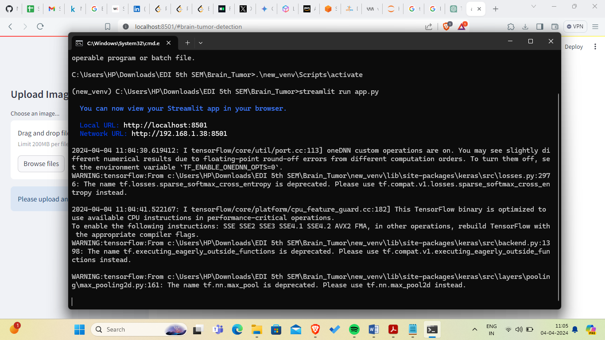

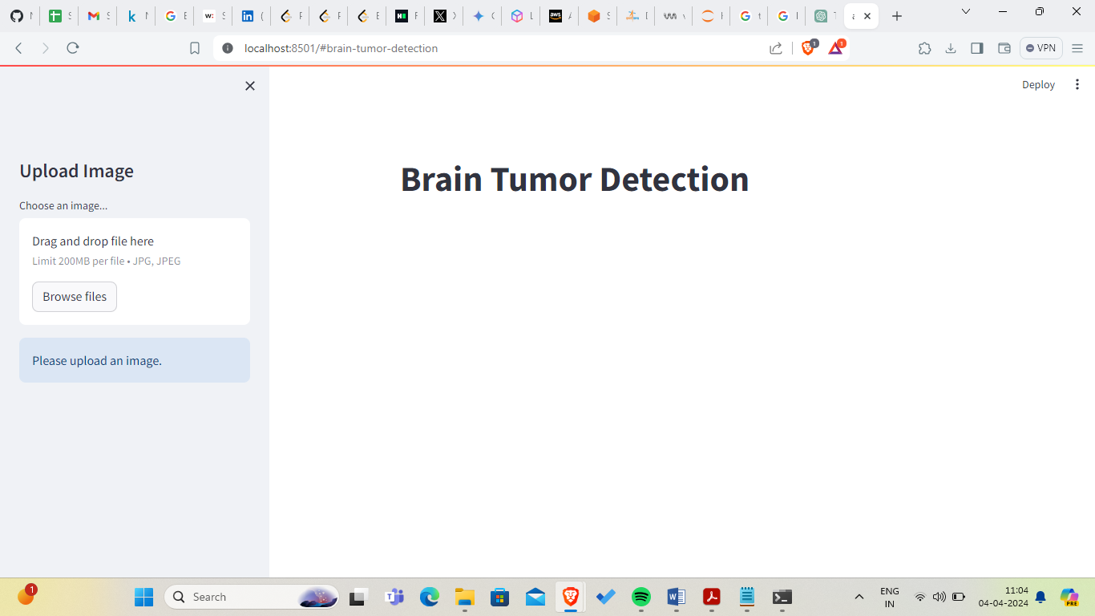

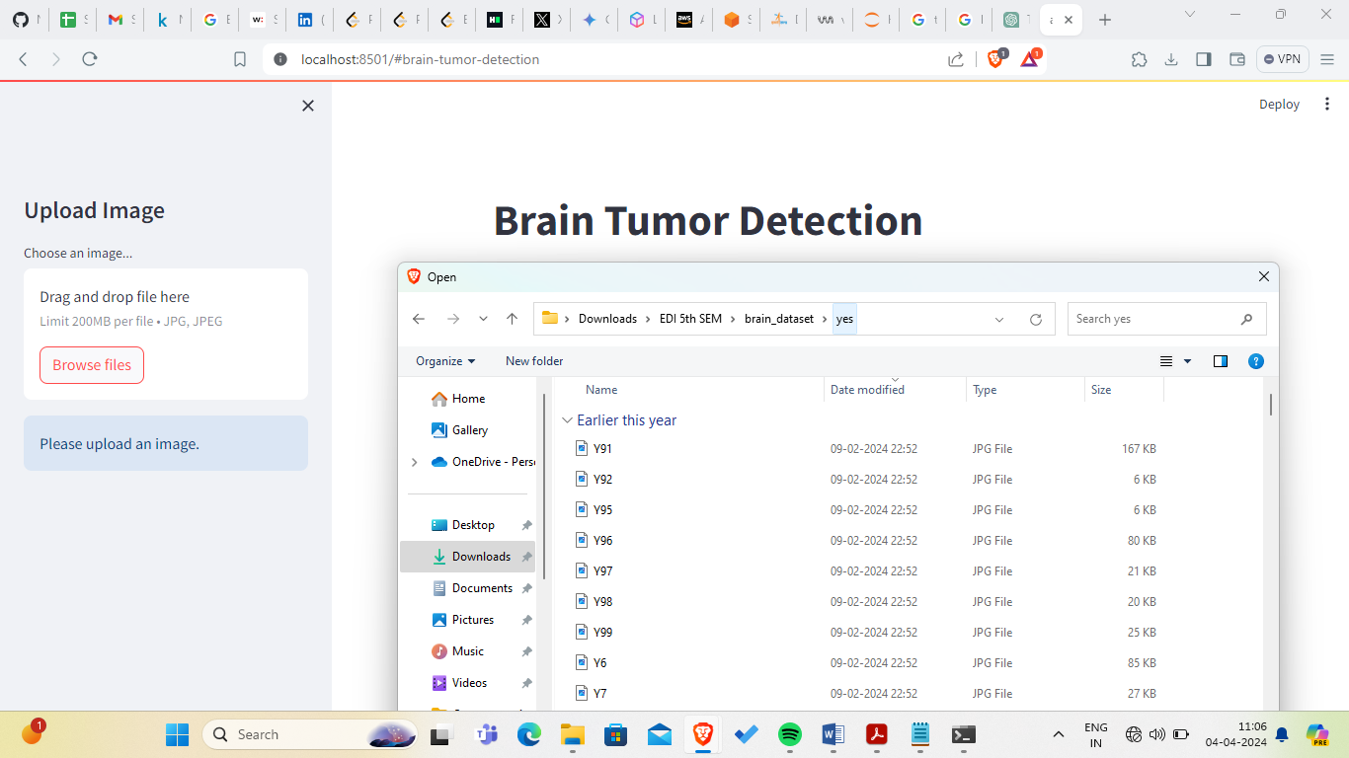

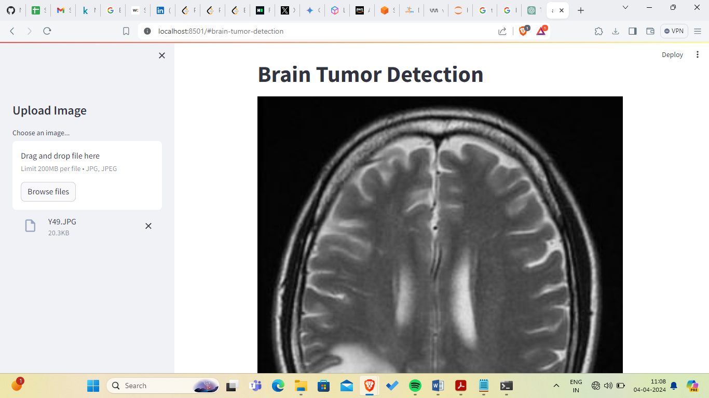

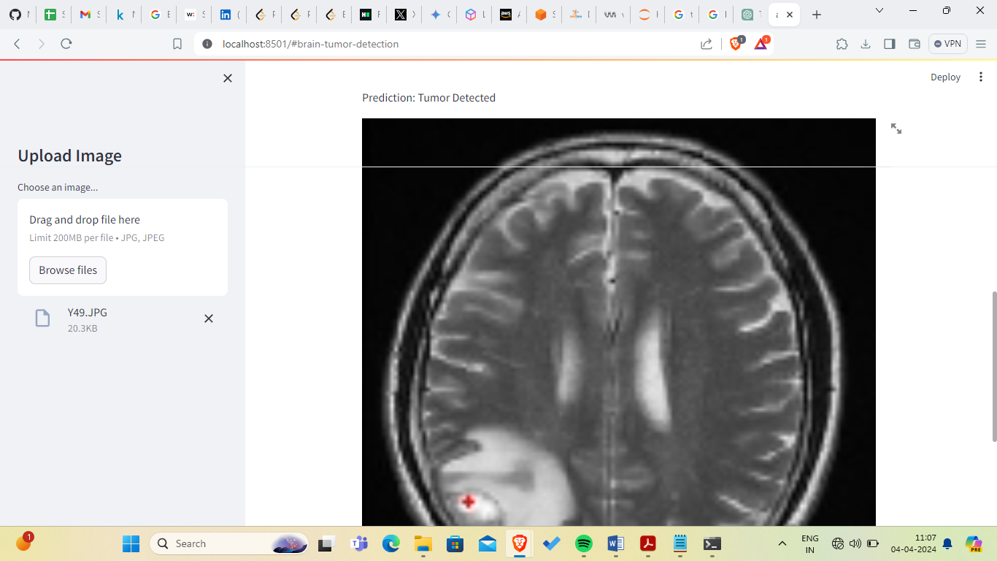

**RESULT**

We utilise a set of critical metrics—accuracy, precision, recall, and F1-score—in our evaluation of our tumour detection algorithm in order to fully analyse its performance. Precision and recall give more complex insights owing to potential class imbalances in medical imaging tasks, but accuracy offers a comprehensive assessment of accurate classifications. Precision is the study of positive prediction accuracy with a focus on accurate identification of positive cases, which is especially important in medical settings where false positives can have serious consequences. The model's recall, or sensitivity, emphasises its capacity to identify all true positive cases while reducing false negatives, which is essential for medical applications such as tumour diagnosis.

Finding a compromise between accuracy and recall, the F1-score offers a more nuanced assessment—particularly in situations when the distribution of classes is not uniform. We also include a confusion matrix, which is a tabular representation that classifies model predictions into true positives, true negatives, false positives, and false negatives, in addition to these metrics. This matrix provides detailed insights into the model's performance and acts as a visual help. False negatives highlight situations in which real tumours are missed, whereas false positives could point to regions that need not be concerned about. When combined, these metrics and the confusion matrix offer a detailed assessment that guarantees a clear comprehension of the model's advantages and disadvantages in the crucial task of tumour identification, enhancing its reliability and practical application.

**FUTURE SCOPE**

Build an app-based user interface in hospitals which allows doctors to easily determine the impact of tumor and suggest treatment accordingly.

Since performance and complexity of ConvNets depend on the input data representation we can try to predict the location as well as stage of the tumor from Volume based 3D images. By creating three dimensional (3D) anatomical models from individual patients, training, planning and computer guidance during surgery is improved.

Using VolumeNet with LOPO (Leave-One-Patient-Out) scheme has proved to give a high training as well as validation accuracy(>95%).In LOPO test scheme, in each iteration, one patient is used for testing and remaining patients are used for training the ConvNets, this iterates for each patient. Although LOPO test scheme is computationally expensive, using this we can have more training data which is required for ConvNets training. LOPO testing is robust and most applicable to our application, where we get test result for each individual patient. So, if classifier misclassifies a patient then we can further investigate it separately.

Improve testing accuracy and computation time by using classifier boosting techniques like using more number images with more data augmentation, fine-tuning hyper parameters, training for a longer time i.e. using more epochs, adding more appropriate layers etc.. Classifier boosting is done by building a model from the training data then creating a second model that attempts to correct the errors from the first model for faster prognosis. Such techniques can be used to raise the accuracy even higher and reach a level that will allow this tool to be a significant asset to any medical facility dealing with brain tumors.

For more complex datasets, we can use U-Net architecture rather than CNN where the max pooling layers are just replaced by upsampling ones. Ultimately we would like to use very large and deep convolutional nets on video sequences where the temporal structure provides very helpful information that is missing or far less obvious in static images. Unsupervised transfer learning may attract more and more attention in the future.

**CONCLUSION**

In summary, our brain tumor detection project harnesses the power of Convolutional Neural Networks (CNNs) to achieve robust and efficient identification of brain abnormalities from medical images. The CNN's ability to automatically learn hierarchical features enables precise tumor localization and classification. By leveraging deep learning in this context, we aim to revolutionize the accuracy and speed of brain tumor diagnosis, ultimately contributing to advancements in medical imaging technology and patient care.

**REFERENCES**

[1] L.Guo,L.Zhao,Y.Wu,Y.Li,G.Xu,andQ.Yan,“Tumordetection in MR images using oneclass immune feature weighted SVMs,” IEEE Transactions on Magnetics, vol. 47, no. 10, pp. 3849–3852,2011.

[2]R.Kumari,“SVMclassificationanapproachondetectingabnormalityinbrainMRIimages,”Inter nationalJournalofEngineeringResearchandApplications,vol.3,pp.1686–1690,2013.

[3] DICOM Samples Image Sets, http://www.osirix-viewer.com/.

[4] “Brainweb:SimulatedBrainDatabase” <http://brainweb.bic.mni.mcgill.ca/cgi/brainweb1>.

[5] Obtainable Online: www.cancer.ca/~/media/CCE 10/08/2015.

[6] J. C. Buckner, P. D. Brown, B. P. O’Neill, F. B. Meyer , C. J. Wetmore,J. H Uhm, "Central nervous system tumors." In Mayo Clinic Proceedings,Vol. 82, No. 10, pp. 1271- 1286, October 2007.

[7] Deepa , Singh Akansha. (2016). - Review of Brain Tumor Detection from tomography. International Conference on Computing for Sustainable Global Development (INDIACom)